Chips and Crackers
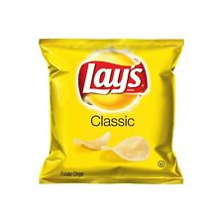 | 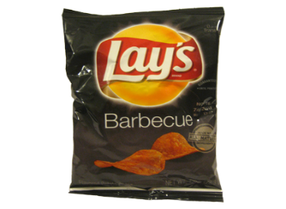 | 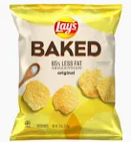 | 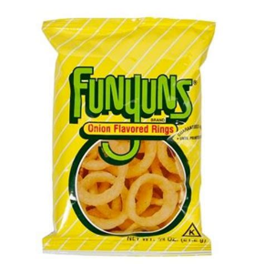
Lays Classic | Lays BBQ | Lays Baked Variety | Funyuns
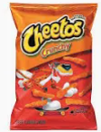 | 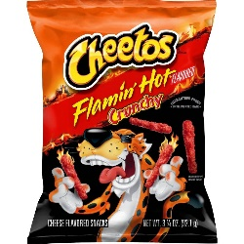 | 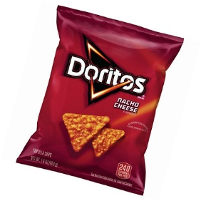 | 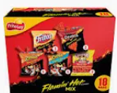
Cheetos Crunchy | Cheetos Crunchy Flamin Hot | Doritos | Lays Flamin Variety
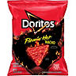 | 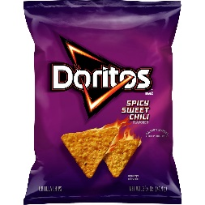 | 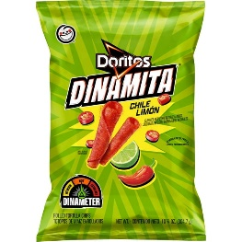 | 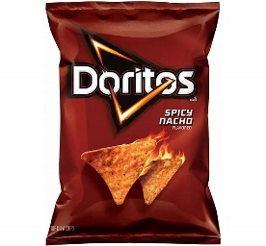
Doritos Flamin Hot | Doritos Spicy Sweet Chili | LAYS Limon Variety | Doritos Spicy Nacho
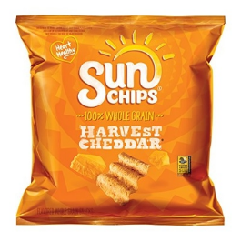 | 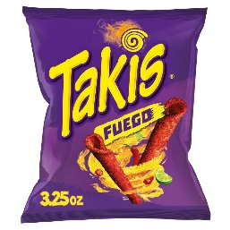 | 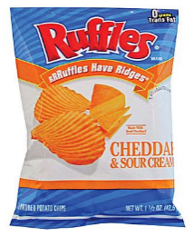 | 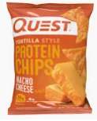
Sun Chips Variety | Takis Fuego | Ruffles Cheddar & Sourcream | Quest Protien Chips
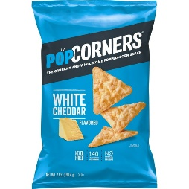 | 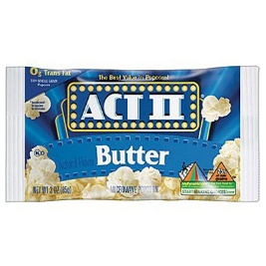 | 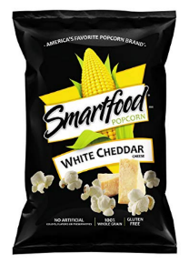 | 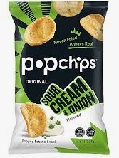
Pop Corners Variety | Act II Individual size | Smart Food | Pop Chips
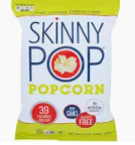 | 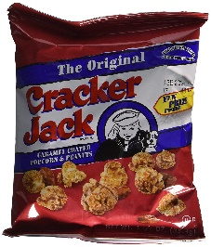 | 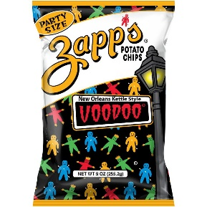 | 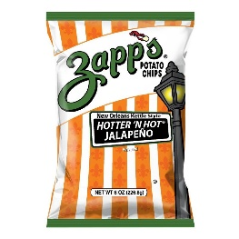
Skinny Pop | Cracker Jacks | Zapps Voodoo | Zapps Variety
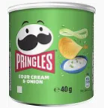 | 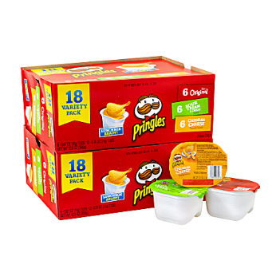 | 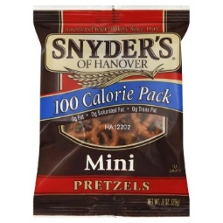 | 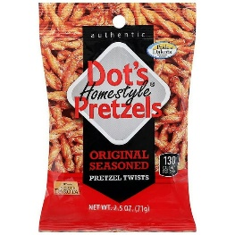
Pringles | Pringles Snack Stacks | Snyders Mini Pretzels | Dots Pretzels
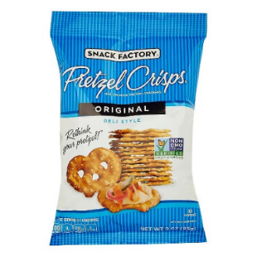 | 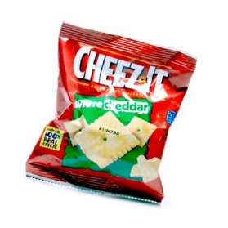 | 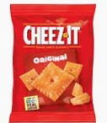 | 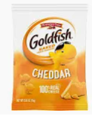
Pretzel Chips | Cheez Its Variety | Cheez Its Variety | Gold Fish
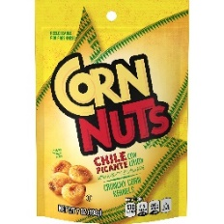 | 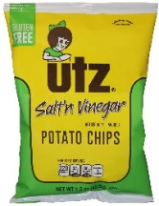 | 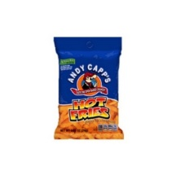
Corn Nuts Chili Picanti | Uta Salt’n Vinegar | Hot Fries
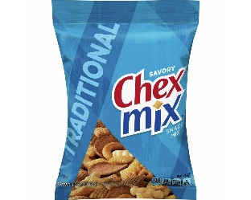 | 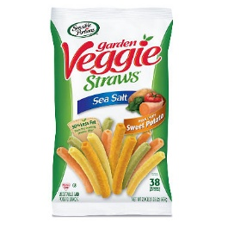 | 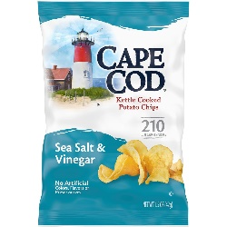 | 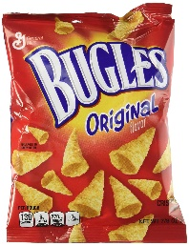
Chex Mix | Veggie Straws | Cape Cod Variety | Bugles

Candy and Protein Bars
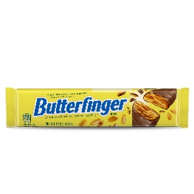 | 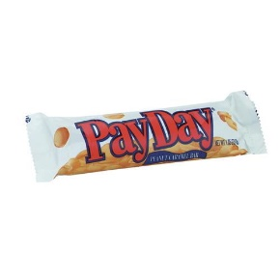
Butterfinger | Payday
 | 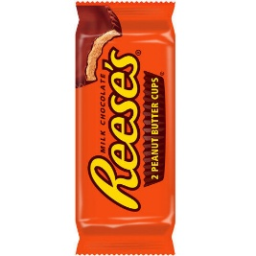 | 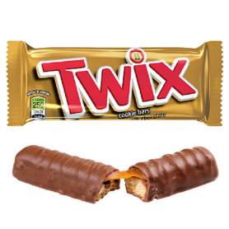 | 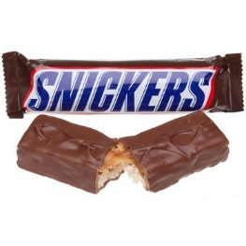
 | Reeses | Twix | Snickers
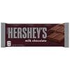 | 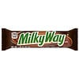 | 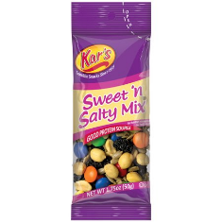 | 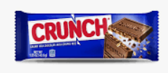
Hersheys | Milky Way | Karrs | Nestle Crunch
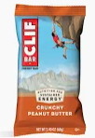 | 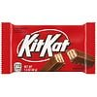 | 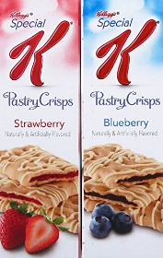 | 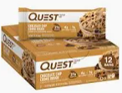
Cliff Bar | KitKat | Nutri Grain | Quest Protein Bar
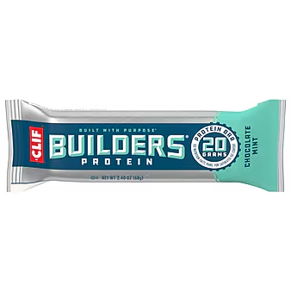 | 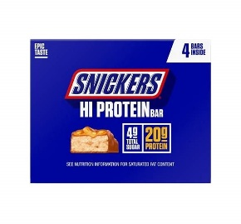 | 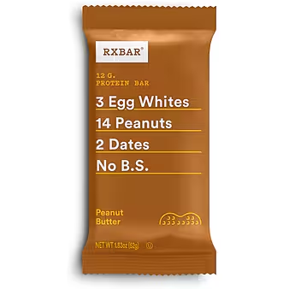 | 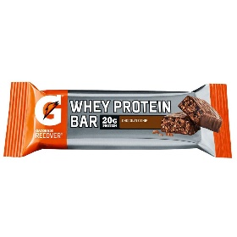
Builders Protein Bar | Snickes Protein Bar | RX Protein Bar | Gatorade Protein Bar
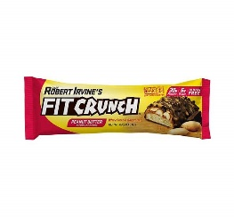 | 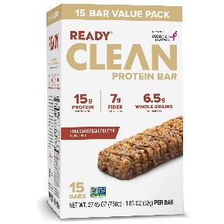 | 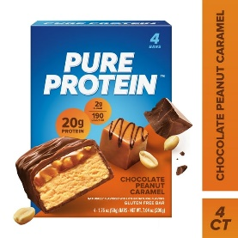 | 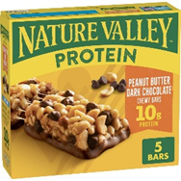
Fit Crunch Protein Bar | Clean Protein Bar | Pure Protein Bar | Nature Valley Protein Bar
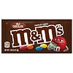 | 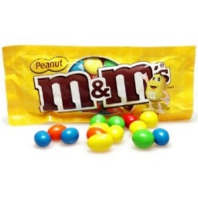 | 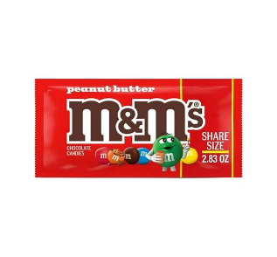 | 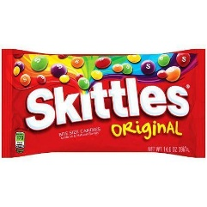
M & Ms | Peanut M & Ms | Peanut Butter M & Ms | Skittles
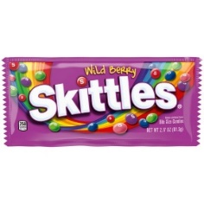 | 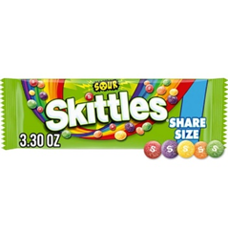 | 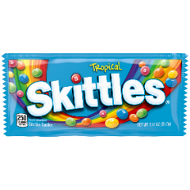 | 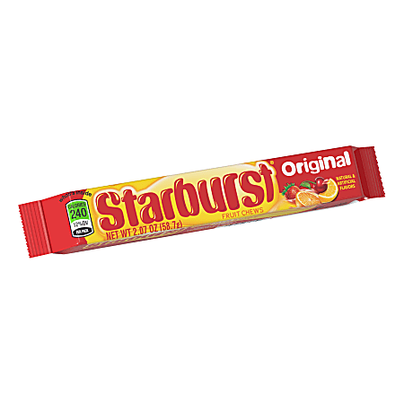
Berry Skittles | Sour Skittles | Tropical Skittles | Starburst
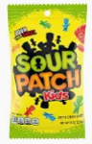 | 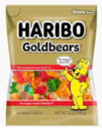 | 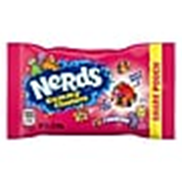 | 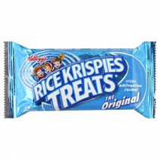
Sourpatch Kids | Gummy Bears | Nerds Clusters | Rice Crispy Treats

Miscellaneous Snacks and sweet treats
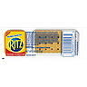 | 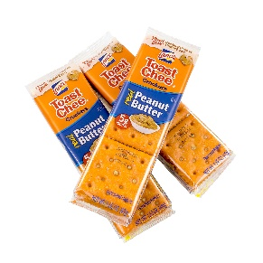 | 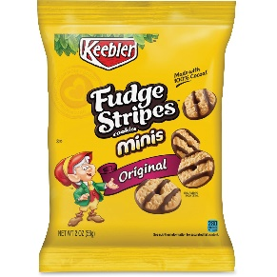 | 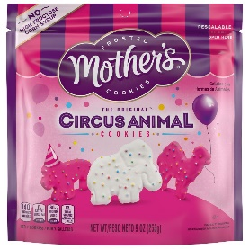
Ritz Cheese and Crackers | Lance Crackers | Keebler Fudge Stripes | Mothers Animnal Cookies
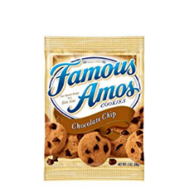 | 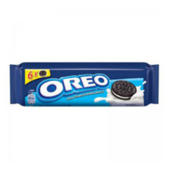 | 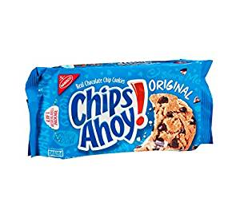 | 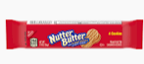
Famous Amos Cookies | Oreo Cookies | Chips Ahoy Cookies | Nutter Butter Cookies
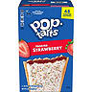 | 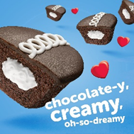 | 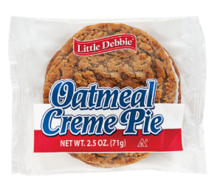 | 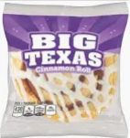
Pop Tarts | Hostess Cupcakes | Oatmeal Pie | Big Texas Cinnamon Roll
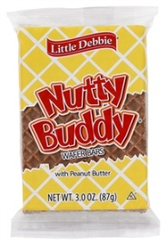 | 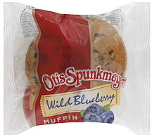 | 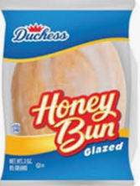 | 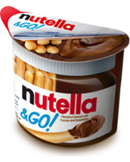
Nutty Buddy Waffer Bar | Otis Spunkmeyer Cupcake | Honey Bun | Nutella
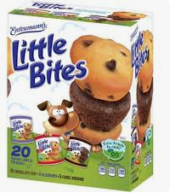 |  | 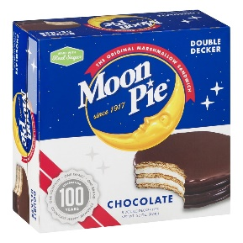 | 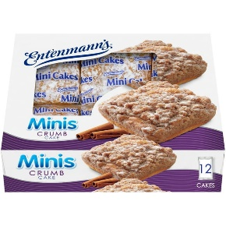
Entenmann's Little Bites |  | Moon Pie | Mini Crumb Cakes
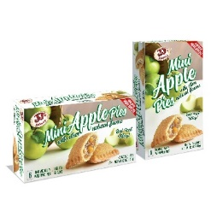 | 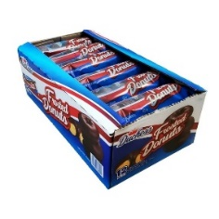 | 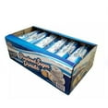 | 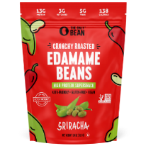
JJ’s Mini Apple Pie | Duchess Mini Choc Donuts | Duchess Mini Powdered Donuts | One Bean Edamame Beans
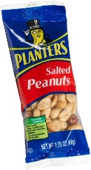 | 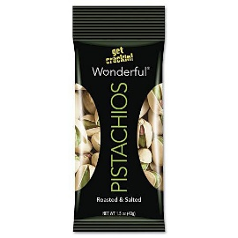 | 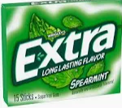 | 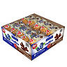
Planter peanuts | Pistachios | Extra Gum | Uncle Walleys Muffins
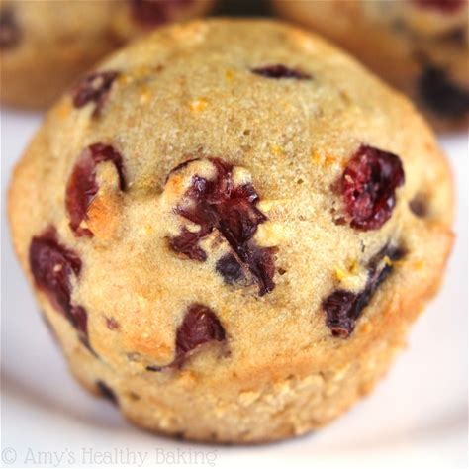 | 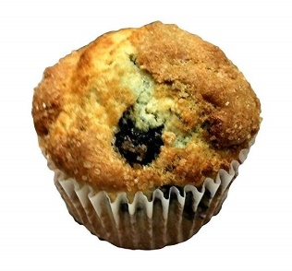 | 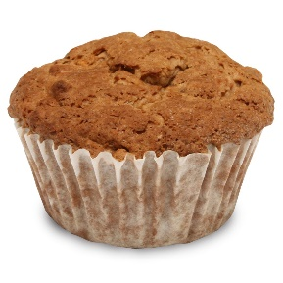 | 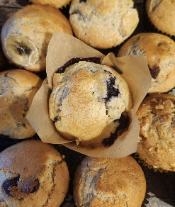
Orange Cranberry Bakery Muffins | Blue Berry Bakery Muffins | Coffee Cake Bakery Muffin | Chocolate Chip Bakery Muffins
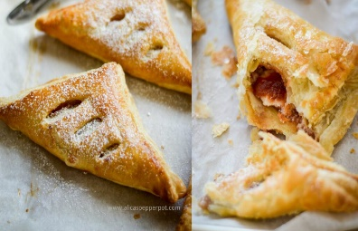 | 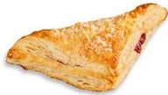 | 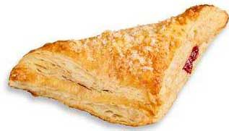 | 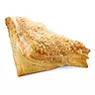
Apple Turnover | Cherry Turnover | Guava Cream Cheese Turnover | Lemon Turnover
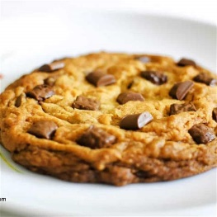 | 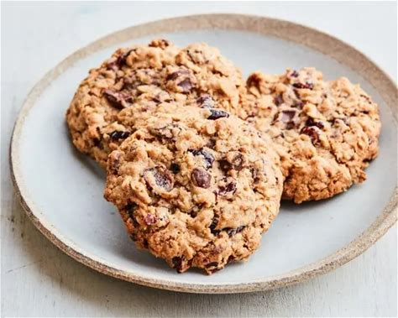 | 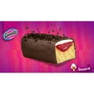 | 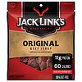
Choco-Chunk Cookies | Cran-Raisen Cookies | Gancito | Jack Links Beef Jerky
Entrees
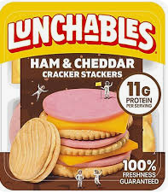 | 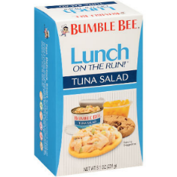 | 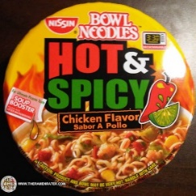 | 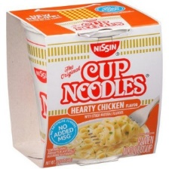
Lunchables | Tuna Salad and Crackers | Nissin Bowl Noodles | Nissin Cup Noodles
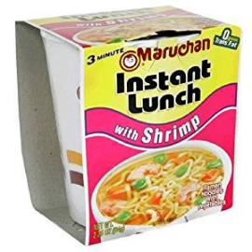 | 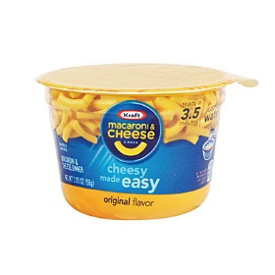 | 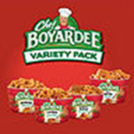 | 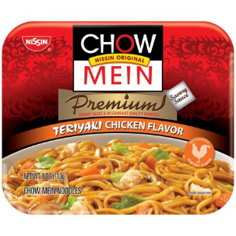
 | Kraft Mac & Cheese | Chef Boyardee Variety | Chicken Terraki Chow Mein
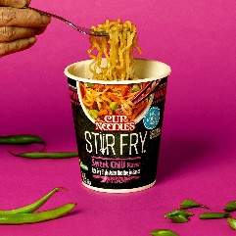
Nissin Stirfry Variety
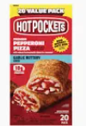 | 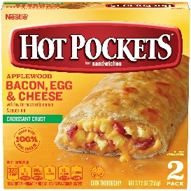 | 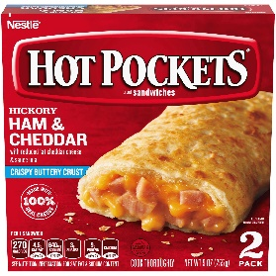 | 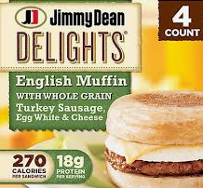
Hot Pocket Pepperoni Pizza | Hot Pocket Bacon Egg and Cheese | Hot Pocket Ham and Cheddar | Jimmy Dean Turkey Sausage Egg and Cheese
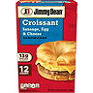 | 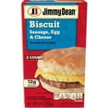 | 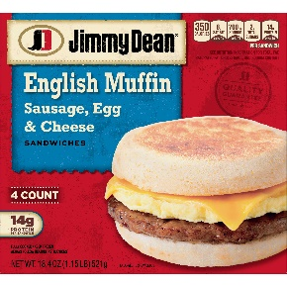 | 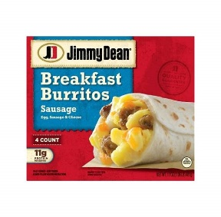
Jimmy Dean Sausage Egg and Cheese Croissant | Jimmy Dean Sausage Egg and Cheese Biscuit | Jimmy Dean Sausage Egg and Cheese Muffin | Jimmy Dean Sausage Egg and Cheese Burrito
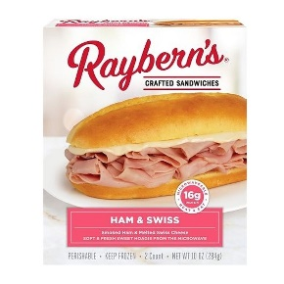 | 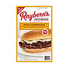 | 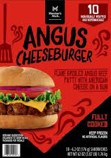 | 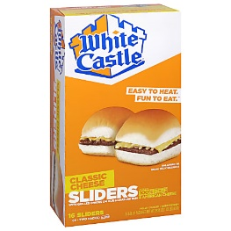
Rayberns Ham and Cheese | Rayberns Philly Cheese and Steak | Angus Burgers | White Castle Burger Sliders
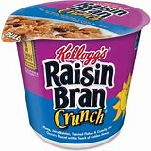 | 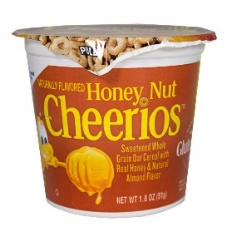 | 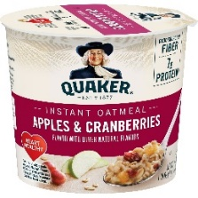 | 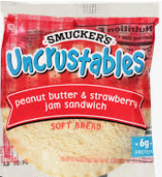
Raisin Bran crunch | Honey nut cheerios | Quaker instant Oats | Uncrustables
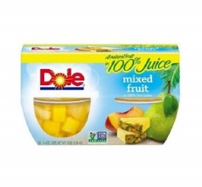
Dole Mango fruit cup

Drinks (Soda cans, bottles, energy, protein)
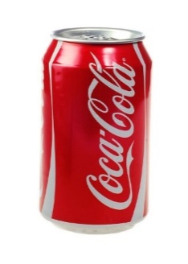 | 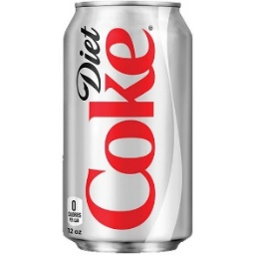 | 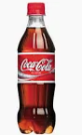 | 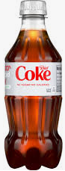
Coke 12 oz | Diet Cok 12 oz | Coke 16 oz | Diet Coke 16 oz
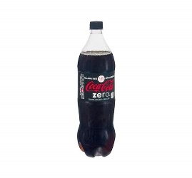 | 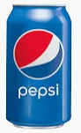 | 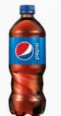 | 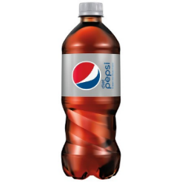
Coke Zero | Pepsi 12 oz | Pepsi 16 oz | Diet Pepsi 16 oz
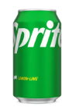 | 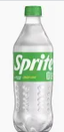 | 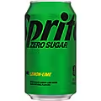 | 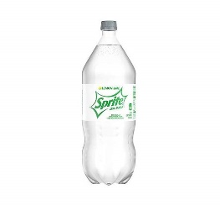
Sprite 12 oz | Sprite 16 oz | Sprite Zero 12 oz | Sprite Zero 16 oz
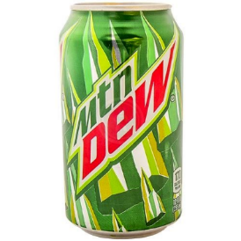 | 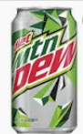 | 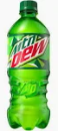 | 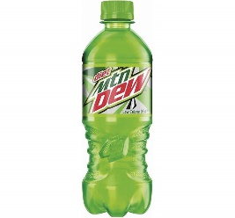
Mountain Dew 12 oz | Mountain Dew Diet12 oz | Mountain Dew 16 oz | Mountain Dew Diet 16 oz
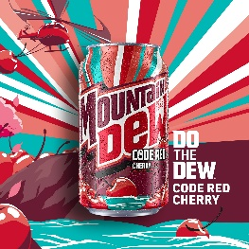 | 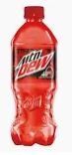 | 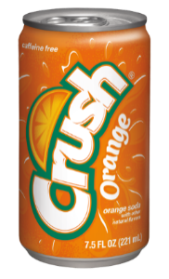 | 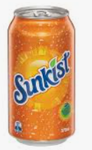
Mountain Dew Code Red 12 oz | Mountain Dew Code Red 16 oz | Orange Crush | Sunkist Orange
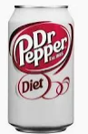 | 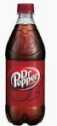 | 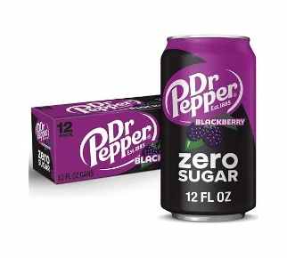 | 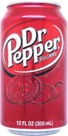
Dr Pepper Diet | Dr Pepper | Dr Pepper Zero Blackberry | Dr Pepper Cherry
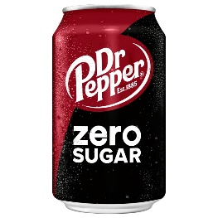 | 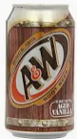 | 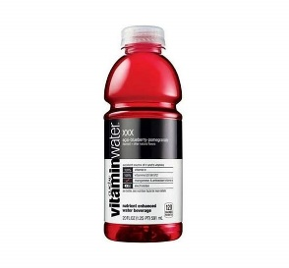 | 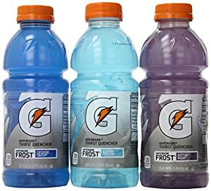
Dr Pepper Zero | A&W Rootbeer | Vitamin Water Variety | Gatorade Variety
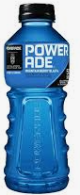 | 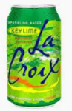 | 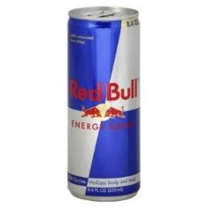 | 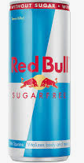
Powerade | LaCroix Variety | Red Bull | Red Bull Sugar Free
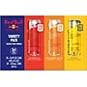 | 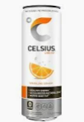 | 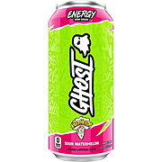 | 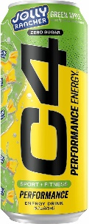
Red Bull Zero Sugar Variety | Celcius | Ghost Energy Variety | C4 Preworkout Variety
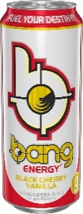 | 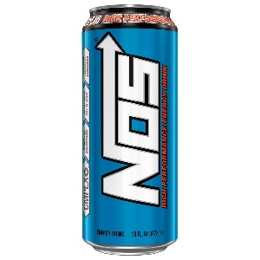 | 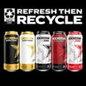 | 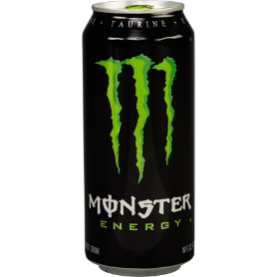
Bang Energy Variety | NOS |  | Monster
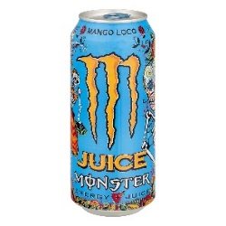 | 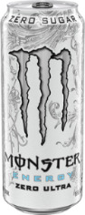 | 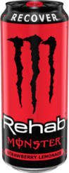 | 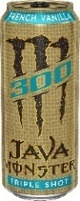
Monster Juice | Monster White | Monster Rehab | Monster Java
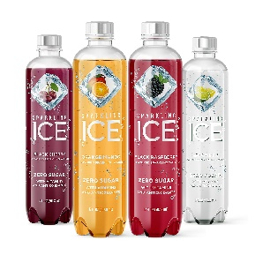 | 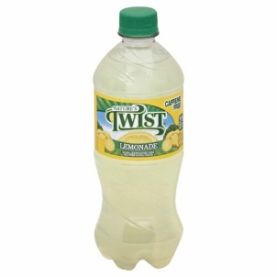 | 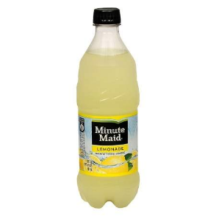 | 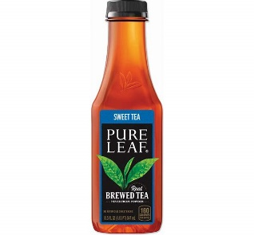
Ice | Twist | Minute Maid | Pure leaf sweet Tea
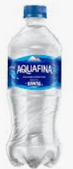 | 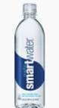 | 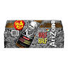 | 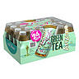
Aquafuba | Smart Water | Arizona Arnold Palmer | Arnold Palmer Green Tea
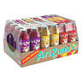 | 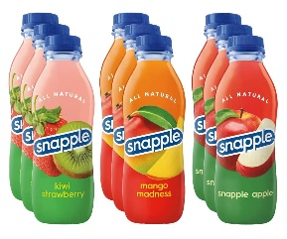 | 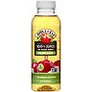 | 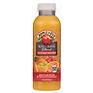
Arizona Juice | Snapple Juice | Apple Juice | Orange Juice
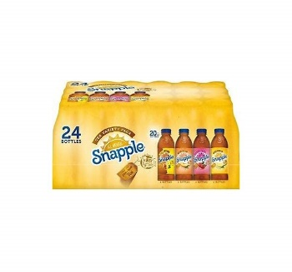 | 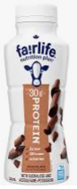 | 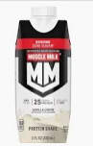 | 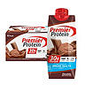
Snapple | Fair life protein milk | Muscle Milk protein | Premier protein
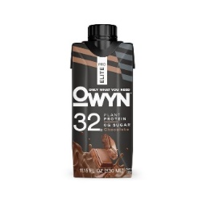 | 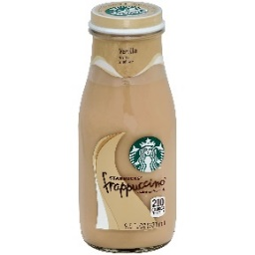 | 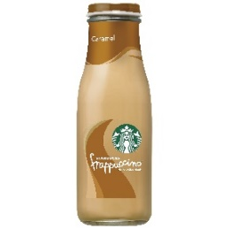 | 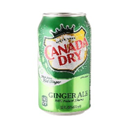
Owyn 32 | Starbucks Vanilla Frappuccino | Starbucks Carmel frappuccino | Canada dry
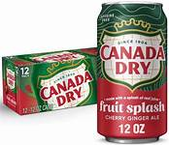
Fruit splash Canada dry

